VISIT THE STORE PAGE - VIRAJIT.COM

- Use dark black color for text instead of grey color
- Increase the font size by a least 2 to 4 spaces to make it easy to read

_________________________________________________________________

Correct the Address;
Remove Shanti lal, from the second line.
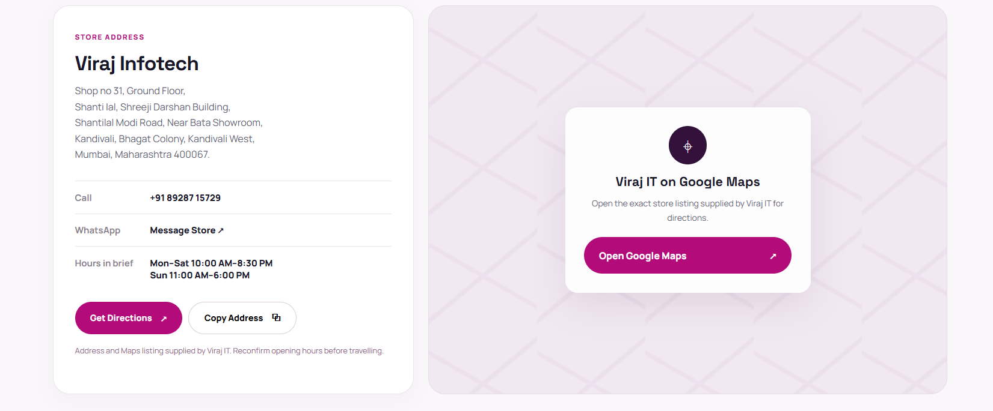

_________________________________________________________________

Update the following reviews in this section






